1. Create Table Name :

Student and Exam

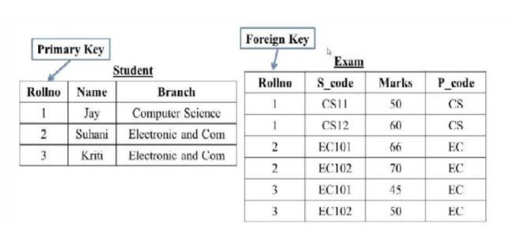

1. ***CREATE TABLE*** Student (

RollNo **INT** ***PRIMARY KEY***,

Name **VARCHAR**(100),

Branch **VARCHAR**(50)

);



1. ***INSERT INTO*** Student (RollNo, Name, Branch) ***VALUES***

(1,"Jay","Computer Science"),

(2,"Suhani","Electronic and Com"),

(3,"Kriti","Electronic and Com");

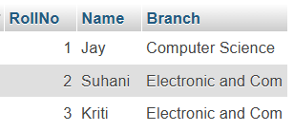

1. ***CREATE TABLE*** Exam (

RollNo **INT**,

S\_code **VARCHAR**(10),

Marks **INT**,

P\_code **VARCHAR**(10),

***FOREIGN KEY*** (RollNo) ***REFERENCES*** Student(RollNo)

);



1. ***INSERT INTO*** Exam (RollNo, S\_code, Marks, P\_code) ***VALUES***

(1,"CS11",50,"CS"),

(1,"CS12",60,"CS"),

(2,"EC101",66,"EC"),

(2,"EC102",70,"EC"),

(3,"EC101",45,"EC"),

(3,"EC102",50,"EC");

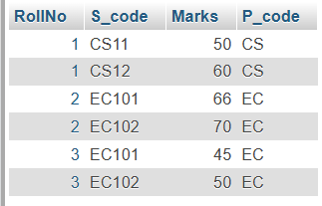

2. Create table given below

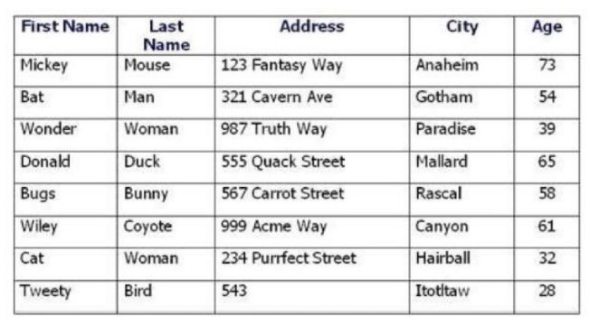

1. ***CREATE TABLE*** Person (

First\_Name **VARCHAR**(50),

Last\_Name **VARCHAR**(50),

Address **VARCHAR**(100),

City **VARCHAR**(50),

Age **INT**

);



1. ***INSERT INTO*** Person (First\_Name, Last\_Name, Address, City, Age) ***VALUES***

("Mickey", "Mouse", "123 Fantasy Way", "Anaheim", 73),

("Bat", "Man", "321 Cavern Ave", "Gotham", 54),

("Wonder", "Woman", "987 Truth Way", "Paradise", 39),

("Donald", "Duck", "555 Quack Street", "Mallard", 65),

("Bugs", "Bunny", "567 Carrot Street", "Rascal", 58),

("Wiley", "Coyote", "999 Acme Way", "Canyon", 61),

("Cat", "Woman", "234 Purrfect Street", "Hairball", 32),

("Tweety", "Bird", "543", "Itotltaw", 28);

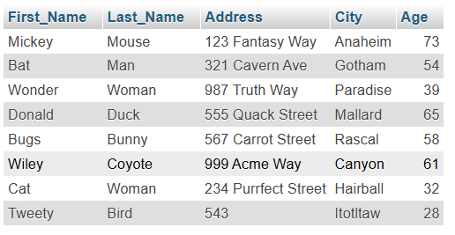

3. Create table given below: Employee and Incentive

Table Name: Employee

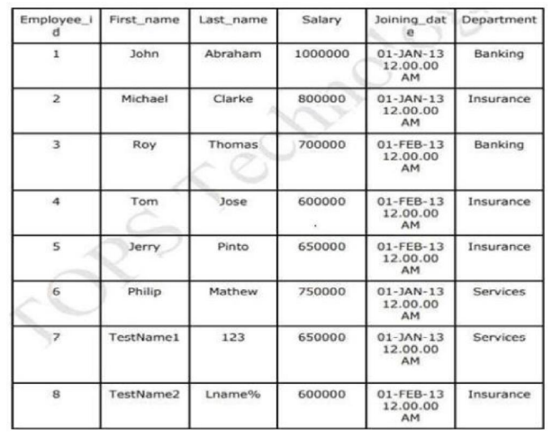

TableName**:** Incentive

**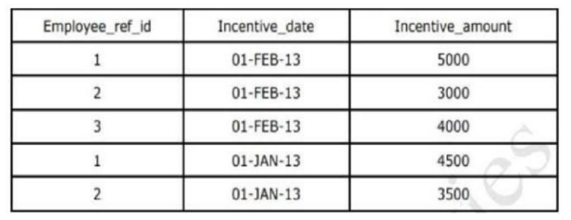**

**Employee table :**

* ***CREATE TABLE*** Employee (

Employee\_id **INT** ***PRIMARY KEY AUTO\_INCREMENT***,

First\_Name **VARCHAR**(30),

Last\_Name **VARCHAR**(30),

Salary **INT**,

Joining\_date **DATETIME**,

Department **VARCHAR**(30)

);



* ***INSERT INTO*** Employee (Employee\_id, First\_Name, Last\_Name, Salary, Joining\_date, Department) ***VALUES***

(1, "John", "Abraham ", 1000000, "2013-01-01", "Banking");

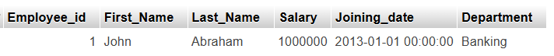

* ***INSERT INTO*** Employee (First\_Name, Last\_Name, Salary, Joining\_date, Department) ***VALUES***

("Michael", "Clarke", 800000, "2013-01-01", "Insurance"),

("Roy", "Thomas", 700000, "2013-02-01", "Banking"),

("Tom", "Jose", 600000, "2013-02-01", "Insurance"),

("Jerry", "Pinato", 650000, "2013-02-01", "Insurance"),

("Philip", "Mathew", 750000, "2013-01-01", "Services"),

("TestName1", "123", 650000, "2013-01-01", "Services"),

("TestName2", "Lname%", 600000, "2013-02-01", "Insurance");

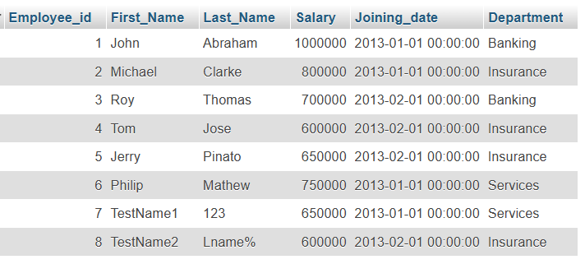

**Incentive table :**

* ***CREATE TABLE*** Incentive(

Employee\_ref\_id **INT**,

Incentive\_date **DATE**,

Incentive\_amount **INT**,

***FOREIGN KEY*** (Employee\_ref\_id) ***REFERENCES*** employee(Employee\_id));



* ***INSERT INTO*** incentive (Employee\_ref\_id, Incentive\_date, Incentive\_amount) ***VALUES***

(1, "2013-02-01", 5000),

(2, "2013-02-01", 3000),

(3, "2013-02-01", 4000),

(1, "2013-01-01", 4500),

(2, "2013-01-01", 3500);

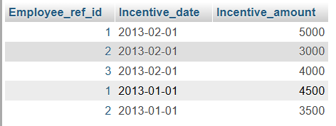

a) Get First\_Name from employee table using Tom name “Employee Name”.

* ***[SELECT](http://localhost/phpmyadmin/url.php?url=https://dev.mysql.com/doc/refman/8.0/en/select.html" \t "mysql_doc)*** First\_Name ***AS*** Employee\_Name

***FROM*** Employee

***WHERE*** First\_Name = "Tom";



b) Get FIRST\_NAME, Joining Date, and Salary from employee table.

* ***SELECT*** First\_Name***,***

***DATE\_FORMAT(***Joining\_date***, '%d-%b-%y %h:%i:%s %p') AS*** Joining\_date***,***

Salary

***FROM*** Employee;

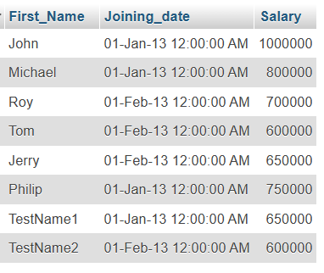

c) Get all employee details from the employee table order by First\_Name Ascending and Salary descending?

First Name Ascending :

* ***SELECT*** ***\* FROM*** Employee

***ORDER BY*** First\_Name ***ASC***;

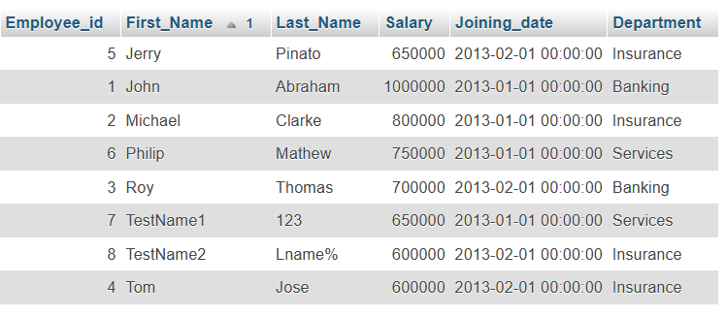

Salary Descending :

* ***SELECT \* FROM*** Employee

***ORDER BY*** Salary ***DESC***;

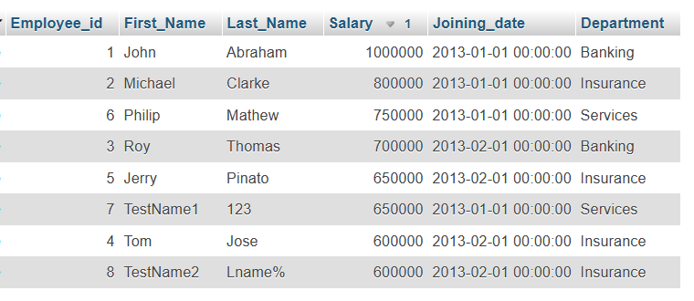

d) Get employee details from employee table whose first name contains ‘J’.

* [***SELECT***](http://localhost/phpmyadmin/url.php?url=https://dev.mysql.com/doc/refman/8.0/en/select.html)***\* FROM*** employee

***WHERE*** First\_Name [***LIKE***](http://localhost/phpmyadmin/url.php?url=https://dev.mysql.com/doc/refman/8.0/en/string-comparison-functions.html%23operator_like) '**%J%**';

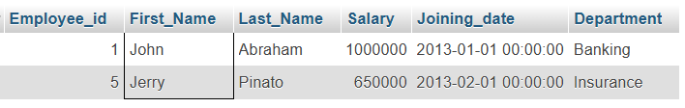

e) Get department wise maximum salary from employee table order by salary ascending?

* ***SELECT \* FROM*** Employee

***WHERE*** (Department, Salary)

***IN*** (***SELECT*** Department, ***MAX***(Salary) ***FROM*** Employee ***GROUP BY*** Department)

***ORDER BY*** Salary ***ASC***;

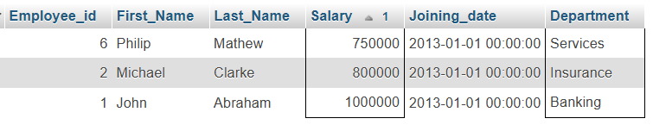

* ***SELECT*** Department, **MAX**(Salary)

***FROM*** employee

***GROUP BY*** Department

***ORDER BY*** Salary **ASC**;

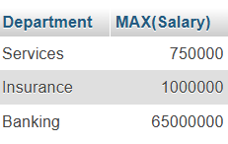

f) Select first\_name, incentive amount from employee and incentives table for those employees who have incentives and incentive amount greater than 3000.

* ***SELECT*** Employee.FIRST\_NAME, Incentive.Incentive\_amount

***FROM*** Employee

***INNER JOIN*** Incentive ***ON*** Employee.Employee\_id = Incentive.Employee\_ref\_id

***WHERE*** Incentive.Incentive\_amount > 3000;

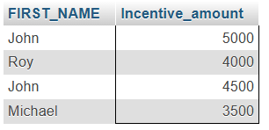

g) Create After Insert trigger on Employee table which insert records in view table.

* ***CREATE TABLE*** Employee\_Trigger (

Id **INT**,

F\_Name **VARCHAR**(20),

L\_Name **VARCHAR**(20),

T\_Salary **INT**,

Join\_Date **DATETIME**,

Dep **VARCHAR**(20),

Fetch\_time **TIMESTAMP**,

Action **VARCHAR**(20)

);



Trigger Creation :

* ***CREATE TRIGGER*** Trigger\_INS

***AFTER INSERT ON*** Employee

***FOR EACH ROW***

***INSERT INTO*** Employee\_Trigger

(Id, F\_Name, L\_Name, T\_Salary, Join\_Date, Dep, Action)

***VALUES***(NEW.Employee\_id, NEW.First\_Name, NEW.Last\_Name, NEW.Salary, NEW.Joining\_date, NEW.Department,"Data Insert !!");

NOW LET WE PERFROM SOME INSERT OPERATIONS AMD SEE WHAT HAPPEN :

* ***INSERT INTO*** Employee(First\_Name, Last\_Name, Salary, Joining\_date, Department) ***VALUES***

("IRON", "MAN", 65000000, "1999-11-16 02.10.00", "BANKING");

* ***INSERT INTO*** Employee(First\_Name, Last\_Name, Salary, Joining\_date, Department) ***VALUES***

(CARRY", "MINATI", 1000000, "2002-08-03 04.21.30", "INSURANCE");

Employee table :

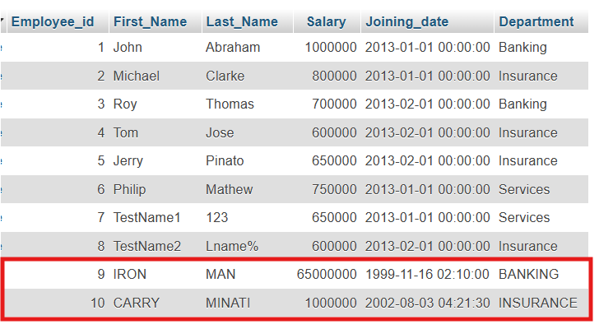

Trigger table :

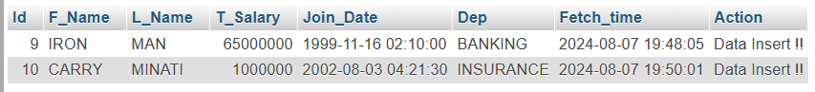

4. Create table given below: Salesperson and Customer.

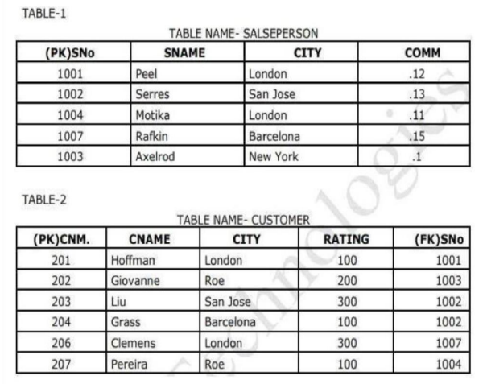

TABLE 1 : SALESPERSON

* ***CREATE TABLE*** SALESPERSON (

SNo **INT** ***PRIMARY KEY NOT NULL***,

SNAME **VARCHAR**(10),

CITY **VARCHAR**(10),

COMM **FLOAT**(2)

);



* ***INSERT INTO*** SALESPERSON (SNo, SNAME, CITY, COMM) ***VALUES***

(1001, "Peel", "London", .12),

(1002, "Serres", "San Jose", .13),

(1004, "Motika", "London", .11),

(1007, "Rafkin", "Barcelona", .15),

(1003, "Axelrod", "New York", .1);

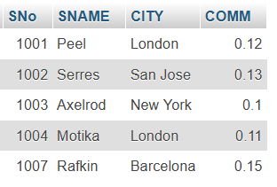

TABLE 2 : CUSTOMER

* ***CREATE TABLE*** CUSTOMER (

CNM **INT**,

CNAME **VARCHAR**(10),

CITY **VARCHAR**(10),

RATING **INT**,

SNo **INT**,

***FOREIGN KEY*** (SNo) ***REFERENCES*** SALESPERSON(SNo)

);



* ***INSERT INTO*** CUSTOMER (CNM, CNAME, CITY, RATING, SNo) ***VALUES***

(201, "Hoffman", "London", 100, 1001),

(202, "Giovanne", "Roe", 200, 1003),

(203, "Liu", "San Jose", 300, 1002),

(204, "Grass", "Barcelona", 100, 1002),

(206, "Clemens", "London", 300, 1007),

(207, "Pereira", "Roe", 100, 1004);

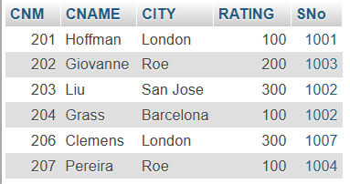

Retrieve the below data from above table

b) Names and cities of all salespeople in London with commission above 0.12

* ***SELECT*** SNAME, CITY

***FROM*** SALESPERSON

***WHERE*** CITY = "London"

***AND*** COMM > 0.12;



c) All salespeople either in Barcelona or in London

* ***SELECT \* FROM*** SALESPERSON

***WHERE*** CITY = "London"

***OR*** CITY = "Barcelona";

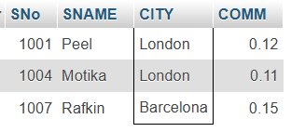

d) All salespeople with commission between 0.10 and 0.12. (Boundary values should be excluded).

* ***SELECT \* FROM*** SALESPERSON

***WHERE*** COMM > 0.10 ***AND*** COMM < 0.12;

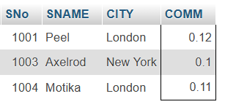

e) All customers excluding those with rating <= 100 unless they are located in Roe.

* ***SELECT \* FROM*** Customer

***WHERE*** (RATING > 100 ***AND*** CITY != “Roe”) ***OR*** CITY = “Roe”;

